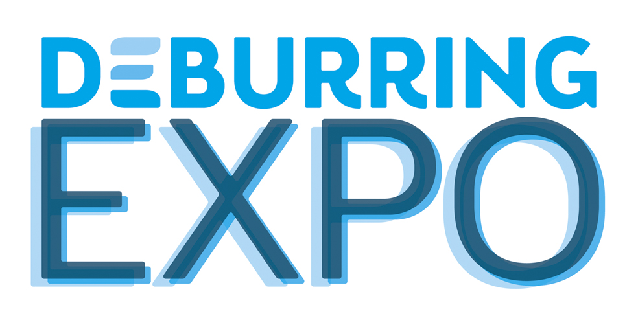
Press Release 4 – July 2019

3rd Leading Trade Fair for Deburring Technology and Precision Surface Finishing,
8 to 10 October 2019 in Karlsruhe (Germany)
Component Quality Masters the Balancing Act

Neuffen, July 2019: Many industrial sectors are currently undergoing future-oriented change. There can be no question that characteristics such as burr-free parts, surface finish and cleanliness have a decisive influence on component quality. As the only international trade fair for deburring technologies and precision surface finishing, DeburringEXPO presents corresponding offerings in a concentrated and comprehensive fashion which is unparalleled by any other event. The 3rd leading trade fair for deburring technologies and precision surface finishing, which will take place at the Karlsruhe Exhibition Centre from 8 to 10 October 2019, will also provide valuable know-how at its bilingual expert forum.

Whether the automotive industry, aviation and aerospace, machinery manufacturing, medical engineering, metrology, precision engineering, sensor technology, tool and mould making or the automotive supplier industry is involved – these and other sectors are currently facing, or are already in the midst of significant change. As different as the challenges may be, one aspect is becoming quite clear: The quality of components is determined to an ever greater extent by freedom from burrs and a requirements-oriented surface finish. The execution of production steps for deburring, rounding and the production of precision surface finishes is thus becoming an increasingly decisive competitive factor. “Amongst other things this is made apparent by the fact that, as opposed to earlier strategies, manufacturing businesses now concern themselves with these tasks and look for appropriate solutions already during the product development phase,” reports Hartmut Herdin, managing director of fairXperts GmbH & Co. KG and promoter of DeburringEXPO.
With their leading trade fair for deburring technologies and precision surface finishing, the organisers have created a globally unique information and communication platform which permits targeted and efficient comparisons of various technologies and performance levels within a focused framework. At the end of June 2019, 155 exhibitors from twelve countries, including nearly all of the market and technology leaders, had already booked their booth floor space for the 3rd DeburringEXPO which will take place at the Karlsruhe Exhibition Centre (Rheinstetten) from the 8th through the 10th of October, 2019. And thus in the fields of deburring, rounding and the production of precision surface finishes, the event will present concentrated and comprehensive offerings which are unmatched by any other technical trade fair anywhere in the world. Amongst other features these offerings include world’s firsts and innovative solutions which permit effective deburring and cleaning of components in a single process, for example. Technologies will also be presented with which components can be manufactured entirely burr-free, as well as solutions for the automation and digitalisation of deburring and surface finishing processes.

Smaller, Lighter, More Precise, Improved Function
Component and application-specific surface finishing requirements vary greatly from industry to industry. For example, the automotive industry and its suppliers are looking for solutions that can further reduce emissions and increase the performance of internal combustion engines – whether they’re used alone or in combination with electric motors in hybrid vehicles. On the other hand they require burr-free components for electric drives, where even the smallest production residues can lead to malfunctions or short-circuiting. Other areas in which burr-free components are absolutely essential for flawless operation include everything from driver assistance systems right on up to autonomous driving. Stricter requirements for surface quality are resulting from the trend towards ever stronger and lighter materials, as well as increasingly high-performance power trains, in the aviation and aerospace industry. Manufacturers of technical medical products are faced with new challenges, amongst other factors due to the new MDR (Medical Device Regulation) which becomes binding on 25 May 2020 after a three-year transition period. For the first time ever, particles are identified in the regulation which can be caused, for example, by burrs.
Reliably deburred workpieces are a basic prerequisite where increasingly stringent particulate cleanliness requirements have to be met, e.g. for precision parts in the PCB supplier sector, for measuring technology and in the optics industry. Regardless of the industry sector, the quality of downstream processes such as joining, sealing, coating and assembly can usually only be assured with the help of burr-free, appropriately finished surfaces. DeburringEXPO also addresses the issues of post-processing for additively manufactured parts. This involves the removal of support structures and residual powder, as well as smoothing and polishing rough, porous surfaces and preparation for subsequent heat treatment or coating.

Bilingual Expert Forum – Know-How and Knowledge as Added Value
DeburringEXPO offers a great deal of knowledge and know-how with its supplementary programme. Theme parks covering the issues of parts cleaning after deburring, the process sequence for sheet metal deburring and post-processing of additively manufactured parts provide information on current developments and trends. Due to its highly practical orientation, the three-day expert forum integrated into DeburringEXPO is an extremely popular source of knowledge. The focal points of the simultaneously interpreted presentations (German <> English) include fundamentals, approaches to process and cost optimisation, reports on best practice applications and current trends, as well as special content provided by the theme parks. Practical examples and benchmark solutions make it possible to gather ideas and inspiration for optimising one’s own processes. Participation is free of charge for visitors at the leading trade fair.
Further information, the entire exhibition programme and a preliminary exhibitor list are available at www.deburring-expo.de.

Captions
Photo: fairXperts_DBE 2017_PR4_2
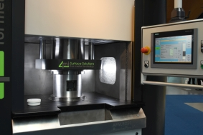
Abrasive flow machining (AFM), also known as flow grinding, is used on conventional as well as additively manufactured components for deburring and the production of precision surface finishes.
Image source: fairXperts
Photo: fairXperts_DBE 2017_PR4_1
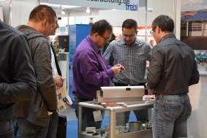
By concentrating technologies, suppliers and solutions within a focused framework, DeburringEXPO provides an overview that can’t be found at any other trade fair.
Image source: fairXperts
- - -
Thank you in advance for sending us a specimen copy or links to online publications.

Contact persons for the editors, and for requesting image files:

SCHULZ. PRESSE. TEXT., Doris Schulz, Journalist (DJV), Landhausstr. 12
70825 Korntal, Germany, phone: +49 (0)711 854085, fax: +49 (0)711 815895,
ds@pressetextschulz.de, www.schulzpressetext.de

fairXperts GmbH & Co. KG, Rita Herdin, Hauptstr. 7, 72639 Neuffen,
Germany, phone: +49 (0)7025 8434-0, fax: +49 (0)7025 8434-20,
info@fairxperts.de, www.fairxperts.de

