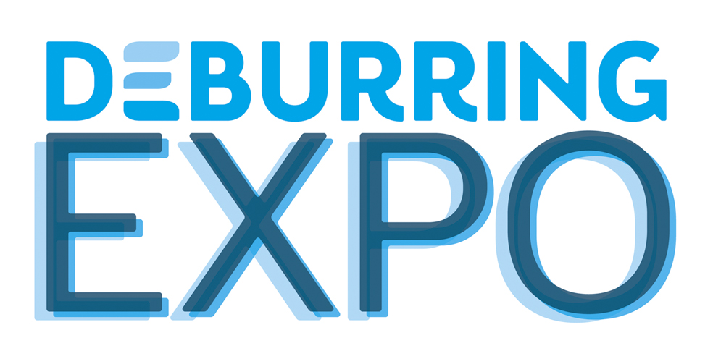
Press Release 1 – October 2018

3rd Trade Fair for Deburring Technology and Precision Surface Finishing, 8 to 10 October 2019 in Karlsruhe (Germany)
DeburringEXPO 2019 – Strong Demand for Booth Floor Space

Neuffen, 17 October 2018: Roughly one year before DeburringEXPO opens its doors for the third time, more than 70 companies have already made firm bookings for their booth floor space. This is a strong indication of growth for the trade fair for deburring technology and precision surface finishing, which will be held in Karlsruhe from the 8th through the 10th of October, 2019. Even greater attention will be focused at the upcoming event on the optimisation of deburring processes for sheet-metal components and additively manufactured parts, as well as parts cleaning after deburring. Added value will be provided by the DeburringEXPO expert forum which is in great demand as a source of knowledge and will offer simultaneously interpreted (German<> English), highly practical presentations.

DeburringEXPO’s exhibition spectrum, which is consistently aligned to deburring, rounding and the production of precision surface finishes, deals with processes which are becoming more and more important in parts manufacturing: despite all of the optimisation measures implemented prior to workpiece processing, residues remain which have to be removed for high quality downstream processes, and in order to assure flawless functioning.
After only two events, the trade fair for deburring technologies and precision surface finishing has already established itself as an international information and procurement platform in this area. This is not only confirmed by the visitors’ high levels of decision-making authority, 94% of whom are involved in company decision-making processes, but rather by the exhibitors’ experience at the trade for as well: “We were able to establish contact with numerous tier 2 and 3 companies and smaller businesses from the automotive and aviation industries at DeburringEXPO, as well as from the fields of hydraulics and pneumatics, with whom we weren’t previously familiar – not only with companies from Germany, but from many other countries as well such as Italy, France, Belgium, Sweden, Denmark, the USA, India and Brazil. Participation at the trade fair has paid off for us and we’ll be back again in two years,” reports Keisuke Kaga, Head of Europe Sales at Sugino Machine Limited from Japan.
Numerous other exhibitors at the last trade fair for deburring technology and precision surface finishing arrived at this conclusion as well, and have thus already made firm bookings for their booth floor space at DeburringEXPO 2019. “Thanks to a high exhibitor return rate, frequently associated with increased booth size, as well as new exhibiting companies who have already decided in favour of participating at the upcoming event, the exhibitor list already included more than 70 companies in mid-October 2018,” says Hartmut Herdin, managing director of trade fair promoters fairXperts GmbH & Co. KG. These currently registered exhibitors will occupy nearly 70% of all exhibition floor space rented out in 2017, which is a good indication that exhibition offerings will once again be significantly increased.

A Single Trade Fair for All Materials and All Industry Sectors
As a technology platform for deburring, rounding and the production of precision surface finishes, DeburringEXPO provides a representative overview of the relevant systems, processes, tools and equipment, as well as measuring, test and analysis systems. The exhibition portfolio covers processing of workpieces and components made of practically all technical materials and from nearly all industry sectors. “At the upcoming trade fair, even more attention will be focused on the deburring of sheet metal components than at previous events, in particular lasered parts and stampings, flame-cut and fine-blanked parts, as well as additively manufactured workpieces. Furthermore, we’ll also place more emphasis on parts cleaning after the deburring process”, adds Hartmut Herdin. Further issues covered by the exhibition portfolio include training and technical literature.

Knowledge as Added Value – Bilingual Expert Forum
Offerings presented by the exhibitors will be rounded out by the integrated 3-day expert forum at DeburringEXPO, which has established itself as a highly popular source of knowledge. With simultaneously interpreted (German <> English) presentations, it provides visitors with the opportunity of expanding their knowledge in the fields of deburring and rounding, as well as the production of precision surface finishes. Beyond this, examples based on actual practice and benchmark solutions provide ideas and stimulation for the optimisation of processes at one’s own company.
Further information, the entire exhibition programme and a preliminary exhibitor list are available at www.deburring-expo.de.

Image source: DeburringEXPO
- - -
Thank you in advance for sending us a specimen copy or links to online publications.

Contact persons for the editors, and for requesting image files:

SCHULZ. PRESSE. TEXT., Doris Schulz, Journalist (DJV), Landhausstr. 12
70825 Korntal, Germany, phone: +49 (0)711 854085, fax: +49 (0)711 815895,
ds@pressetextschulz.de, www.schulzpressetext.de

fairXperts GmbH & Co. KG, Rita Herdin, Hauptstr. 7, 72639 Neuffen,
Germany, phone: +49 (0)7025 8434-0, fax: +49 (0)7025 8434-20,
info@fairxperts.de, www.fairxperts.de

