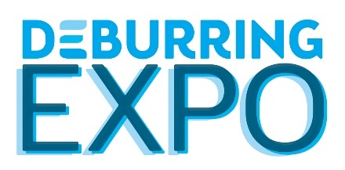
Press Release 4

5th Leading Trade Fair for Deburring Technology and Precision Surface Finishing
10 to 12 October 2023 at the Karlsruhe Exhibition Centre in Germany
DeburringEXPO – New Solutions and Know-How for Efficient and Sustainable Deburring and Surface Finishing

Neuffen, August 2023: The deburring and surface finishing sector will meet again at DeburringEXPO at the Karlsruhe Exhibition Centre from the 10th through the 12th of October, 2023. Market and technology leaders, hidden champions, start-ups and research institutes will present innovative and further developed solutions and services for current and future challenges in these quality and cost-relevant manufacturing steps. The internationally unique spectrum of exhibitor offerings is rounded out with an attractive supplementary programme including theme parks and a bilingual expert forum.

Manufacturing companies are currently facing major challenges that will have to be mastered in order to remain competitive. A somewhat lower priority is often assigned to production steps such as deburring, edge rounding, component cleaning and surface finishing – unjustifiably so, because enormous potential is available for optimisation in these production processes. As the only international information and procurement platform for these disciplines, DeburringEXPO identifies opportunities targeted at improvement, streamlining and enhanced resource efficiency in the relevant processes for investment decision-makers, developers, design engineers and technical purchasing agents, as well as manufacturing and production managers. “This is reflected on the one hand by the numerous innovations and further developments presented by the exhibitors at the leading trade fair for deburring technologies and precision surface finishing. Furthermore, solutions are also provided for dealing with the current shortage of skilled personnel,” reports Hartmut Herdin, managing director of private trade fair promoters fairXperts GmbH & Co. KG. “On the other hand, the supplementary programme with its various theme parks and the expert forum is also geared towards offering companies inspiration and suggestions for optimising processes, reducing costs and increasing sustainability.”

Innovations and Further Developments for All Applications
Whether market and technology leaders, hidden champions, start-ups or research institutes are involved – exhibitors traditionally take advantage of DeburringEXPO to premiere innovations and further developments to its expert audience. These include world’s firsts such as a self-learning deburring robots for toothed parts and the first chamfering cutter with a V-shaped cutting edge, which prevents secondary burrs and thus the need for additional, downstream deburring processes. New systems and methods for fully automated deburring and cleaning of components in a single process – using high-pressure water jet techniques as well as ultrasound or dry processes with CO₂ granulate – will also be presented. New and further developed products, technologies, processes and services in the field of micromachining, as well as for energy and resource-efficient production of application-oriented surfaces, is also facilitating optimisation targeted at boosting competitiveness.

Theme Parks Covering Aspects with Relevance for Competition
The three theme parks at this year’s DeburringEXPO also provide inspiration for mastering current and future challenges. For example, the theme park for “Quality Assurance in the Deburring Process” provides targeted information on various measuring methods, as well as their strengths and limitations, in order to verify compliance with ever stricter specifications in the areas of deburring, edge rounding and surface finishing. The special show on “Automated Deburring” presents the most up-to-date options for automated polishing, grinding and deburring of components with robots, which also plays a role in confronting the current shortage of skilled personnel. Whether before or after deburring, technical cleanliness in accordance with the specified requirements is an essential prerequisite for the quality of downstream processes, and thus for high-quality components as well. Corresponding methods and processes will be presented in the “Cleaning After Deburring” theme park.

Bilingual Expert Forum – Knowledge, Trends and Best Practice Applications
“As a supplement to the exhibitors’ cross-technology, multi-material and inter-industry spectrum of solutions, DeburringEXPO ensures an effective transfer of knowledge at the integrated, three-day expert forum,” explains Hartmut Herdin. The programme, featuring a total of 23 simultaneously interpreted presentations (German <> English) by experts from industry and science, is divided into five thematic blocks: “mechanical deburring”, “quality assurance”, “automated deburring with industrial robots”, “cleaning after deburring” and “non-mechanical deburring”. Presentation focal points include fundamentals, approaches to process and cost optimisation, reports on best practice applications and current trends. Trade fair visitors are admitted free of charge and will also receive a free copy of the updated and expanded brochure entitled “Basic Knowledge in Deburring Technology” in German and English.
Further information, the entire exhibition portfolio and the complete agenda for the expert forum, as well as the provisional exhibitor list, can be found at www.deburring-expo.de.

Captions

Photo: Botzian-Kirch_Cobot

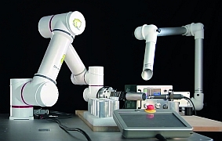

The exhibitors will not only present various innovative solutions for automated deburring – a special show area will also be dedicated to this topic.

Image source: Botzian & Kirch GmbH

Photo: Kempf_Burless Chamfering Cutter

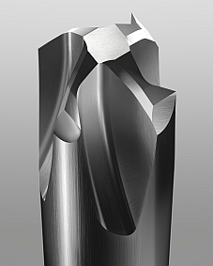

Numerous innovations and further developments will also be presented in the deburring tools area, for example the world’s first chamfering cutter with a V-shaped cutting edge that fully excludes the occurrence of any secondary burrs.

Image source: Kempf

Foto: fairXperts_FF

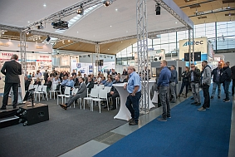
The focal points of the three-day, integrated expert forum with a total of 23 simultaneously interpreted presentations (German <> English) include fundamentals, approaches to process and cost optimisation and reports on best practice applications and current trends, as well as on content provided by the theme parks.
Image source: fairXperts

- - -
Thank you in advance for sending us a specimen copy or links to online publications.

Contact persons for the editors, and for requesting image files:
SCHULZ. PRESSE. TEXT., Doris Schulz, Journalist (DJV), Landhausstr. 12,
770825 Korntal, Germany, phone: +49 (0)711 854085, ds@pressetextschulz.de, www.schulzpressetext.de

fairXperts GmbH & Co. KG, Hartmut Herdin, Hauptstr. 7, 72639 Neuffen,
Germany, phone: +49 (0)7025 8434-0, info@fairxperts.de, www.fairxperts.de

