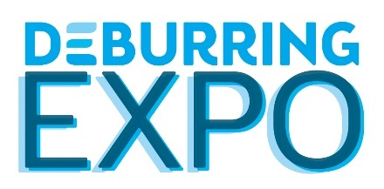
Press Release 3

5th Leading Trade Fair for Deburring Technology and Precision Surface Finishing
10 to 12 October 2023 at the Karlsruhe Exhibition Centre
Megatrends Looking for Solutions

Neuffen, June 2023: Whether the mobility and energy transition, sustainability, health or safety is involved – global megatrends have a profound effect on industrial production. They’re also impacting demands placed on burr-free components, as well as cleanliness and surface finishing quality. As the only international trade fair for deburring technologies and precision surface finishing, DeburringEXPO presents corresponding offerings in a concentrated fashion which is unparalleled by any other event. The bilingual expert forum and various theme parks will also ensure an effective transfer of knowledge at the 5th leading trade fair at the Karlsruhe Exhibition Centre from the 10th through the 12th of October, 2023.

Components and the demands placed on their performance and reliability have changed dramatically in recent years in areas such as automotive and machinery manufacturing, medical and pharmaceuticals technology, aviation and aerospace, energy and fluid technology, as well as measuring, sensor and analysis technology. This results in new and different tasks in production steps involving deburring, edge rounding, cleaning and surface finishing. At the same time, factors such as the energy and resource efficiency of the utilised processes and their integration into interlinked production are becoming increasingly important. As a leading international information and procurement platform, DeburringEXPO presents new and further developed, as well as time-tested solutions to this end. The 5th leading trade fair for deburring technology and precision surface finishing will be held at the Karlsruhe Exhibition Centre in Germany from the 10th through the 12th of October, 2023.

The Right Process for Every Application
“Thanks to its multi-industry, multi-material focus, DeburringEXPO supports companies from all industry sectors in their search for suitable processes,” reports Gitta Steinmann, project manager at private trade fair promoters fairXperts GmbH & Co. KG. “The entire spectrum of technologies, processes, tools and services for deburring, edge rounding, cleaning and surface finishing are presented. The strengths and the limits of the various processes ranging from mechanical deburring with tools to vibratory grinding, brush deburring and blasting with solid and liquid media, right on up to machining with special technologies, can be discussed directly on site.” The latter includes, for example, ultrasonic deburring which makes it possible to selectively deburr edges and cross-drilled holes in a fully automated, verifiable process. Since this energy-efficient process can be used for nearly any material, the range of suitable workpieces covers everything from micro parts for the optics and watchmaking industries to precision tools for machining, all the way up to components used in machinery and vehicle manufacturing weighing 15 kilograms.
Abrasive flow machining (AFM) also covers a very broad range of applications. It’s used for the deburring, edge rounding and polishing of components in the automotive and aviation industries, as well as in energy technology, fluid and medical engineering, extrusion technology and mould and tool making. The strengths of this process result from its ability to machine internal areas and surfaces which are difficult to access, for example in additively manufactured components.
In the case of ECM (electrochemical machining), the machining process is based on the anodic dissolution of the respective metal. Nearly all metals can be machined, in particular high-alloy materials such as nickel-based and titanium alloys, and hardened materials. In addition to deburring, selective edge rounding and polishing, the technology is also used for contouring and shaping components, as well as for burr-free drilling – for example in the aviation and aerospace industry, the automotive and toolmaking sectors, as well as in medical, microsystems and energy technology.
Laser deburring is an effective method for removing fine burrs and flakes from the outer contours of very delicate, thin-walled workpieces. Even the edges of drill-holes with diameters of just a few tenths of a millimetre can be machined. The process is also distinguished by very high processing speeds.
Thermal energy machining (TEM) permits the simultaneous removal of external and internal burrs by means of vaporisation. It’s used primarily for metal workpieces such as hydraulic manifolds, and for components made of thermoplastics from which internal and external burrs have to be removed – even from very difficult to access places.

Bilingual Expert Forum – Effective Knowledge Transfer for Added Value
As a complement to the exhibitor presentations, the supplementary programme at DeburringEXPO offers a great deal of knowledge and know-how. Theme parks including “Automated Deburring”, “Cleaning After Deburring” and “Quality Assurance in the Deburring Process” provide information on current developments and trends. Due to its highly practical orientation, the 3-day expert forum integrated into DeburringEXPO is an extremely popular source of knowledge. The focal points of the simultaneously interpreted presentations (German <> English) include fundamentals, approaches to process and cost optimisation, reports on best practice applications and current trends, as well as special content provided by the theme parks. Trade fair visitors are admitted free of charge and will also receive a free copy of the updated and expanded brochure entitled “Basic Knowledge in Deburring Technology” in German and English.
Further information, the entire exhibition portfolio and the agenda for the expert forum, as well as the provisional exhibitor list, can be found at:
www.deburring-expo.de.

Captions

Photo: ATL_TEM

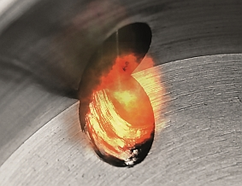

In TEM deburring, the burr to be removed is oxidised by a chemical reaction occurring between the material and the process gas. The process can be used for workpieces made of various metals, as well as for thermoplastics with complex geometries and numerous, difficult to access deburring points.

Image source: ATL Luhden

Photo: UltraTec_US-Entgraten

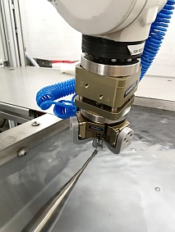

Ultrasonic deburring takes place in a water basin in which components are advanced to the high-frequency ultrasonic sonotrode.

Image source: ultraTEC

Photo: EMAG ECM

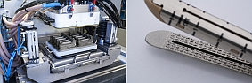
Not only can workpieces be deburred with the ECM process, it can also be used to produce components – in this case a stapler used for closing wounds. Microstructuring takes place in a multiple tool.
Image source: EMAG ECM

- - -
Thank you in advance for sending us a specimen copy or links to online publications.

Contact persons for the editors, and for requesting image files:
SCHULZ. PRESSE. TEXT., Doris Schulz, Journalist (DJV), Landhausstr. 12,
770825 Korntal, Germany, phone: +49 (0)711 854085, ds@pressetextschulz.de, www.schulzpressetext.de

fairXperts GmbH & Co. KG, Hartmut Herdin, Hauptstr. 7, 72639 Neuffen,
Germany, phone: +49 (0)7025 8434-0, info@fairxperts.de, www.fairxperts.de

