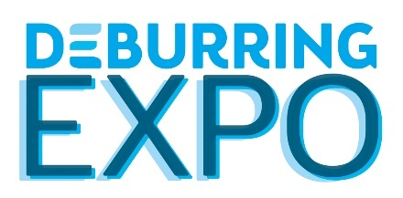

5th Leading Trade Fair for Deburring Technology and Precision Surface Finishing
10 to 12 October 2023 – Preparation has Begun
DeburringEXPO – the Industry Meet for Deburring and Finishing

Neuffen, February 2023: Requirements and processes are changing in many ways for the manufacturing industries as a result of structural and technological change. Where deburring and the production of precision surface finishes are concerned, this results in the need for new and modified solutions. The 5th DeburringEXPO will present innovations and trends for these production steps, which are becoming increasingly relevant for quality and efficiency, at the Karlsruhe Exhibition Centre from the 10th through the 12th of October, 2023. This makes it an absolute must for industry players in order to exchange information with interested parties and customers about their investment plans. With its bilingual expert forum, the leading trade fair for deburring technologies and precision surface finishing also hosts one of Europe’s most coveted sources of knowledge.

Its clear focus on deburring and edge rounding, as well as the production of precision surface finishes, has made DeburringEXPO the leading trade fair in Europe for these manufacturing steps. It’s a must-attend event for companies from the industry sector, and its dates are firmly anchored in the trade fair calendar. This hardly comes as a surprise, because international expert visitors always arrive at the event with concrete tasks, RFQs and projects, for which efficient solutions are being sought. This was confirmed amongst others by Iris Münz, commercial director of Ultratec Anlagentechnik Münz GmbH, after participating at the last event in 2021: “We were pleasantly surprised – not only by the number of leads, but rather by their quality as well. Visitors came to us with very precise requirements for specific components.” Furthermore, a very high proportion of the participating expert visitors are involved in operational investment decisions, i.e. an average of about 95% at each and every DeburringEXPO.

The Ideal Information Platform for All Industries and Materials
Beyond this, the exhibition portfolio of the leading trade fair for deburring technologies and precision surface finishing covers processes that are also becoming increasingly important in parts manufacturing throughout all industry sectors. “Companies are being confronted with ever-stricter or modified and new requirements, where previously used processes and technologies are reaching their limits. For example, these include more demanding specifications for surface quality, more complex component geometries and a changing component spectrum, as well as new and modified materials and manufacturing processes,” reports Hartmut Herdin, managing director of private trade fair promoters fairXperts GmbH & Co. KG. Additional factors involve process automation and digitalisation, which not only ensure the reproducibility required for many applications, but can also alleviate the shortage of skilled personnel. Not least of all, climate protection, the efficient use of energy and resources and cost optimisation in parts production are becoming increasingly important as competitive factors. DeburringEXPO covers this range of requirements in a targeted, thematically specific manner. It provides a complete overview of up-to-date, innovative solutions, shares information on current trends in various industries and offers insights into research projects. And thus the leading trade fair for deburring technologies and precision surface finishing creates an ideal environment for the presentation of current and new solutions, for early technology monitoring, and for the establishment and expansion of partnerships and networks. As of the end of January, these convincing arguments had already prompted 70 companies to make firm booth space bookings – including almost all market and technology leaders. “Based on numerous enquiries and reservations, we’re expecting 150 to 180 national and international exhibitors, which is a significant increase as compared with the last event in 2021 and almost matches pre-corona levels,” adds Gitta Steinmann, DeburringEXPO project manager.

Supplementary Programme with Theme Parks and Expert Forum
With theme parks covering the issues of “Component Cleaning”, “Quality Control” and “Automation”, the supplementary programme at the upcoming DeburringEXPO will focus on three aspects that specifically contribute to meeting current and future requirements for component surface quality.
The integrated 3-day expert forum at DeburringEXPO with simultaneously interpreted presentations (German <> English) is one of the most sought-after sources of knowledge anywhere in Europe. It enables visitors to enhance their know-how in the fields of deburring, rounding and component cleaning, as well as in the production of precision surface finishes, by presenting new solutions, research results and benchmark applications.
Further information, the entire exhibition programme and a preliminary exhibitor list are available at www.deburring-expo.de.

Captions
Photo: FX_DBE 2021_3
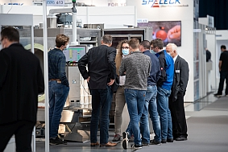
Its clear focus on the production steps involving deburring, rounding and the production of precision surface finishes makes DeburringEXPO the ideal presentation platform for current and new solutions.

Photo: FX_DBE_2021_10
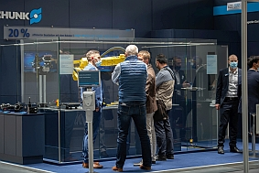
DeburringEXPO is the Europe-wide meeting place for parts manufacturers from all industries who are seeking solutions for their requirements.
Image source: fairXperts GmbH & Co. KG
- - -
Thank you in advance for sending us a specimen copy or links to online publications.

Contact persons for the editors, and for requesting image files:

SCHULZ. PRESSE. TEXT., Doris Schulz, Journalist (DJV), Landhausstr. 12,
770825 Korntal, Germany, phone: +49 (0)711 854085, ds@pressetextschulz.de, www.schulzpressetext.de

fairXperts GmbH & Co. KG, Hartmut Herdin, Hauptstr. 7, 72639 Neuffen,
Germany, phone: +49 (0)7025 8434-0, info@fairxperts.de, www.fairxperts.de

